INDEX

Sr. no | Aim | Date | Page No | Sign
1 | Install, configure and run Hadoop and HDFS and  explore HDFS. |  | 2
2 | Implement word count / frequency programs using MapReduce. |  | 9
3 | Implement an application that stores big data in Hbase / MongoDB and manipulate it using R / Python. |  | 13
4 | Implement Decision tree classification techniques. |  | 20
5 | Implement SVM classification techniques. |  | 21
6 | REGRESSION MODEL: Import data from web storage. Perform Logistic Regression to find the relationship between variables affecting student admission based on GRE score, GPA, and  student rank. Check model fit using require(foreign) and require(MASS). |  | 24
7 | MULTIPLE REGRESSION MODEL: Apply multiple regressions on the above dataset, if data has a continuous independent variable. |  | 26
8 | CLASSIFICATION MODEL: a. Install relevant package for classification. b. Choose classifier for classification problem.  c. Evaluate the performance of classifier. |  | 28
9 | CLUSTERING MODEL: a. Clustering algorithms for unsupervised classification. b. Plot the cluster data using R visualizations. |  | 30

Practical 1
Aim : Install, configure and run Hadoop and HDFS ad explore HDFS.
Steps to Install Hadoop
- Install Java JDK 1.8
- Download Hadoop and extract and place under C drive
- Set Path in Environment Variables
- Config files under Hadoop directory
- Create folder datanode and namenode under data directory
- Edit HDFS and YARN files
- Set Java Home environment in Hadoop environment
- Setup Complete. Test by executing start-all.cmd There are two ways to install Hadoop, i.e.
- Single node
- Multi node
Here, we use multi node cluster.
- Install Java
  - – Java JDK Link to download
o https://www.oracle.com/java/technologies/javase-jdk8-downloads.html
  - – extract and install Java in C:\Java
  - – open cmd and type -> javac -version
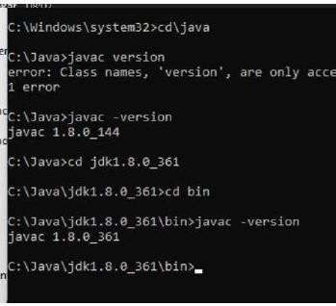

- Download Hadoop
https://www.apache.org/dyn/closer.cgi/hadoop/common/hadoop-3.3.0/hadoop-3.3.0.tar.gz

- • right click .rar.gz file -> show more options -> 7-zip->and extract to C:\Hadoop-3.3.0\
- 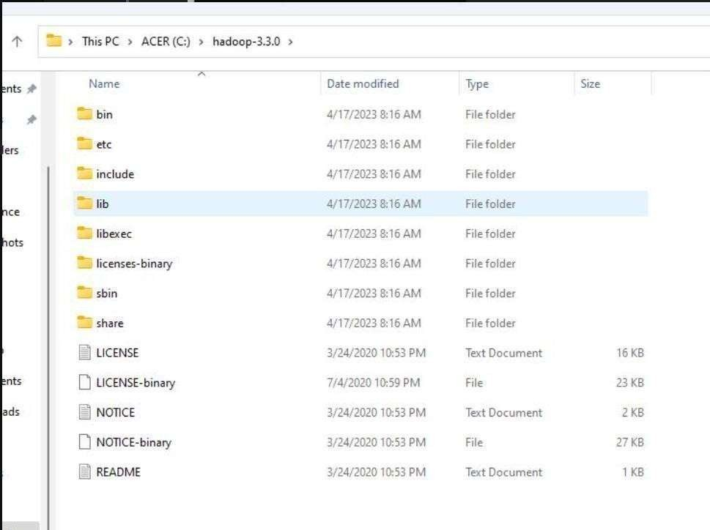

- Set the path JAVA_HOME Environment variable

- Set the path HADOOP_HOME Environment variable Click on New to both user variables and system variables. Click on user variable -> path -> edit-> add path for Hadoop and java upto ‘bin’
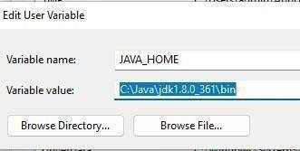
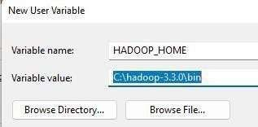
Click Ok, Ok, Ok.
- Configurations

Edit file C:/Hadoop-3.3.0/etc/hadoop/core-site.xml,
paste the xml code in folder and save
<configuration>
<property>
<name>fs.defaultFS</name>
<value>hdfs://localhost:9000</value>
</property>
</configuration>
======================================================
Rename “mapred-site.xml.template” to “mapred-site.xml” and edit this file C:/Hadoop-3.3.0/etc/hadoop/mapred-site.xml, paste xml code and save this file.
======================================================
<configuration>
<property>
<name>mapreduce.framework.name</name>
<value>yarn</value>
</property>
</configuration>
======================================================
Create folder “data” under “C:\Hadoop-3.3.0”
Create folder “datanode” under “C:\Hadoop-3.3.0\data” Create folder “namenode” under “C:\Hadoop-3.3.0\data”
======================================================
Edit file C:\Hadoop-3.3.0/etc/hadoop/hdfs-site.xml, paste xml code and save this file.
<configuration>
<property>
<name>dfs.replication</name>
<value>1</value>
</property>
<property>

<name>dfs.namenode.name.dir</name>
<value>/hadoop-3.3.0/data/namenode</value>
</property>
<property>
<name>dfs.datanode.data.dir</name>
<value>/hadoop-3.3.0/data/datanode</value>
</property>
</configuration>
======================================================
Edit file C:/Hadoop-3.3.0/etc/hadoop/yarn-site.xml, paste xml code and save this file.
<configuration>
<property>
<name>yarn.nodemanager.aux-services</name>
<value>mapreduce_shufle</value>
</property>
<property>
<name>yarn.nodemanager.auxservices.mapreduce.shufle.class</name>
<value>org.apache.hadoop.mapred.ShufleHandler</value>
</property>
<property>
<name>yarn.resourcemanager.address</name>
<value>127.0.0.1:8032</value>
</property>
<property>
<name>yarn.resourcemanager.scheduler.address</name>
<value>127.0.0.1:8030</value>
</property>
<property>
<name>yarn.resourcemanager.resource-tracker.address</name>
<value>127.0.0.1:8031</value>

</property>
</configuration>
======================================================
- Edit file C:/Hadoop-3.3.0/etc/hadoop/hadoop-env.cmd

Find “JAVA_HOME=%JAVA_HOME%” and replace it as set JAVA_HOME="C:\Java\jdk1.8.0_361"
======================================================
- Download “redistributable” package

Download and run VC_redist.x64.exe
- Hadoop Configurations

Download bin folder from https://github.com/s911415/apache-hadoop-3.1.0-winutils – Copy the bin folder to c:\hadoop-3.3.0. Replace the existing bin folder.
- copy "hadoop-yarn-server-timelineservice-3.0.3.jar" from ~\hadoop-3.0.3\share\hadoop\yarn\timelineservice to ~\hadoop-3.0.3\share\hadoop\yarn folder.

- Format the NameNode
– Open cmd ‘Run as Administrator’ and type command “hdfs namenode –format”
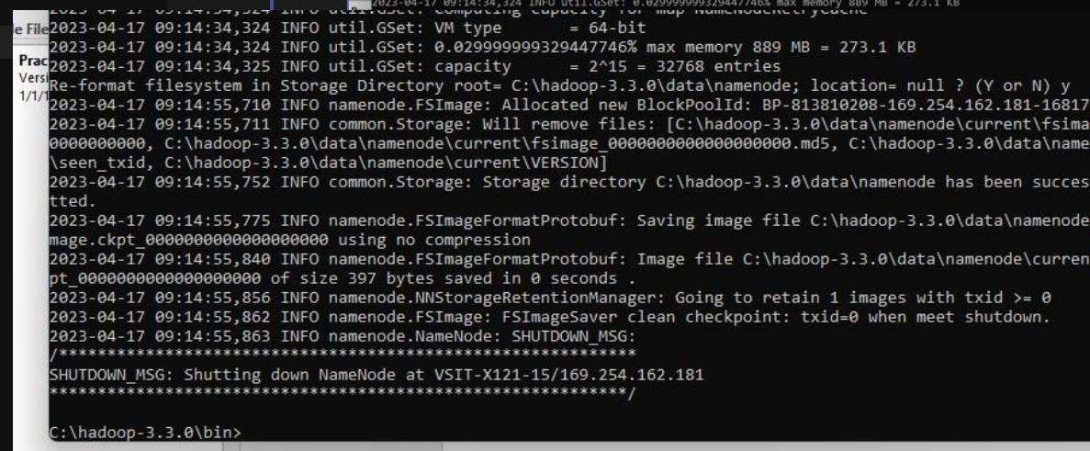
- Testing
- Open cmd ‘Run as Administrator’ and change directory to C:\Hadoop-3.3.0\sbin
- type start-all.cmd

OR
- type start-dfs.cmd
- type start-yarn.cmd
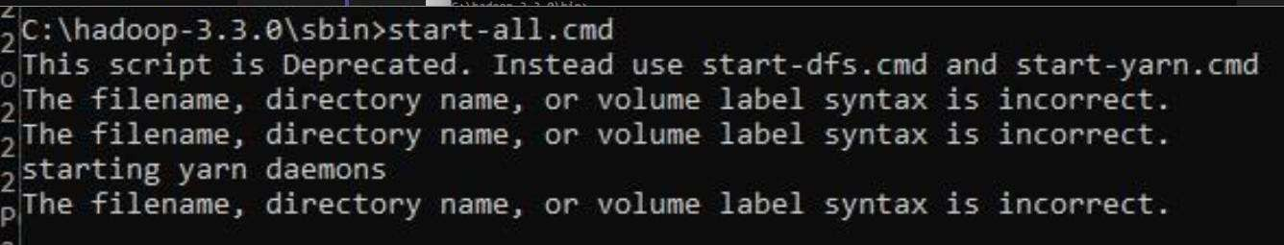
- You will get 4 more running threads for Datanode, namenode, resouce manager and node manager
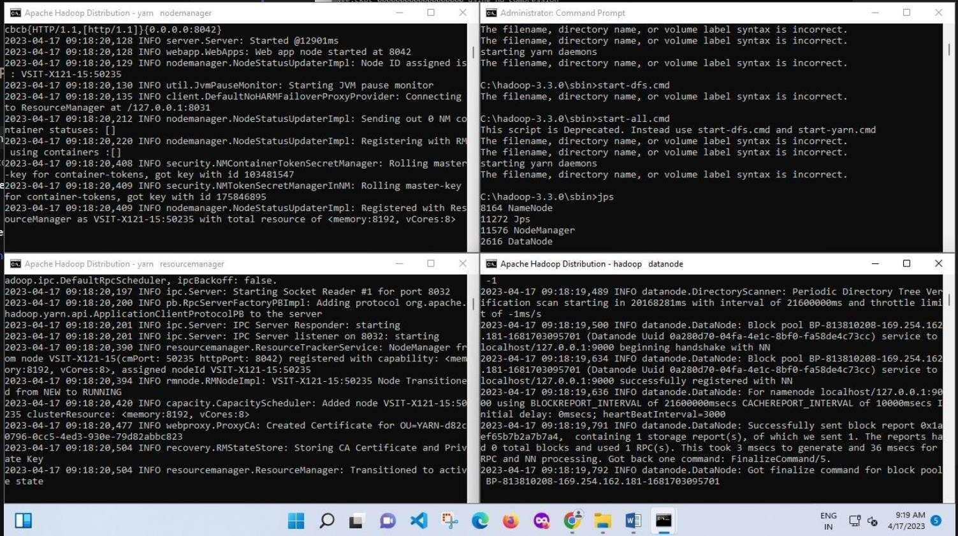
Output:
- Type JPS command to start-all.cmd command prompt, you will get following output.
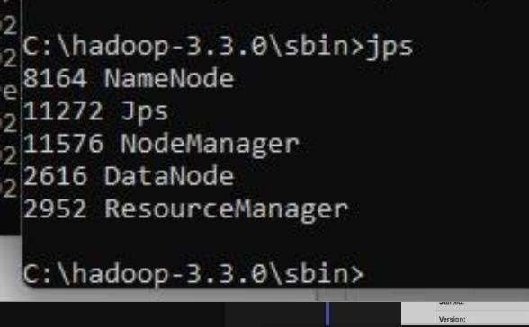
- Run http://localhost:9870/ from any browser

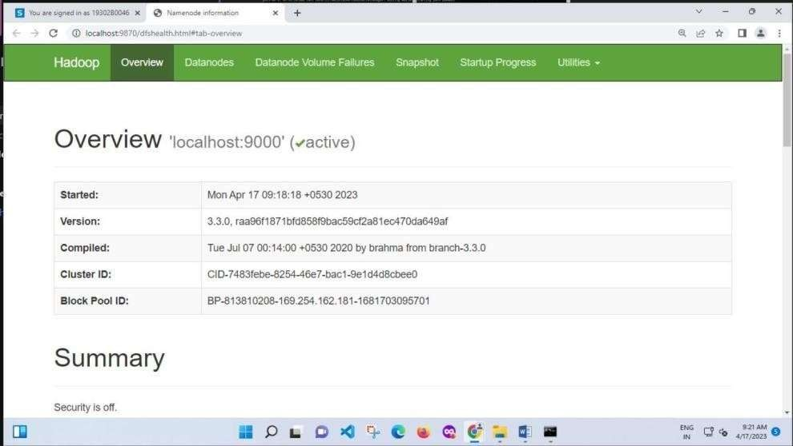


Practical 2
Aim: Implement word count / frequency programs using MapReduce
Solution:
C:\hadoop-3.3.0\sbin>start-dfs.cmd C:\hadoop-3.3.0\sbin>start-yarn.cmd
Open a command prompt as administrator and run the following command to create an input and output folder on the Hadoop file system, to which we will be moving the sample.txt file for our analysis.
C:\hadoop-3.3.0\bin>cd\
C:\>hadoop dfsadmin -safemode leave
DEPRECATED: Use of this script to execute hdfs command is deprecated. Instead use the hdfs command for it.
Safe mode is OFF
C:\>hadoop fs -mkdir /input_dir
Check it by giving the following URL at browser http://localhost:9870
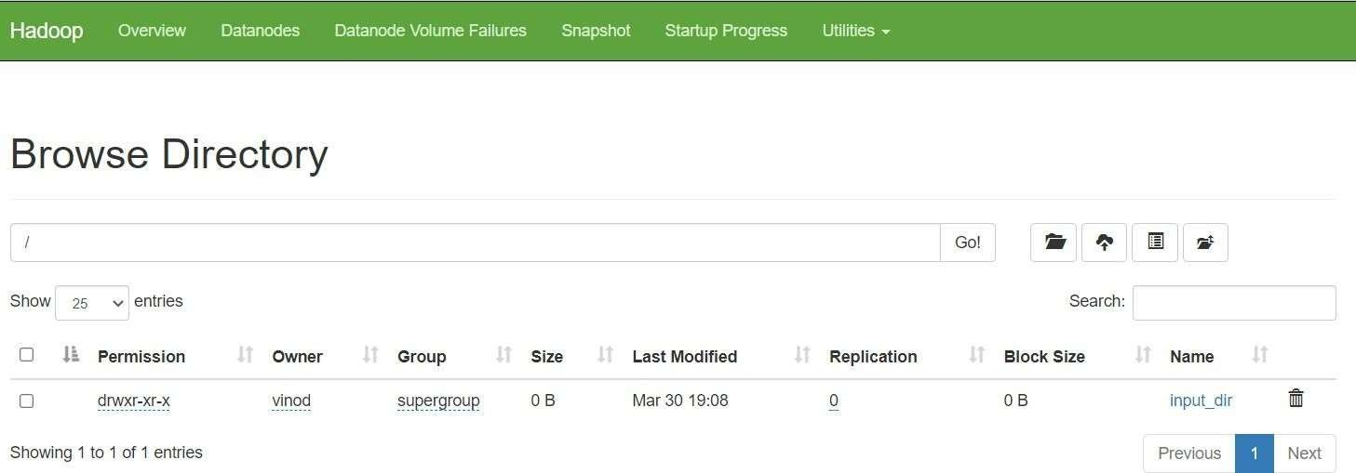
Utilities -> browse the file system
Copy the input text file named input_file.txt in the input directory (input_dir) of HDFS. Make a file in c:\input_file.txt and write following content in it.
Hadoop Window version is easy compared to Ubuntu version Now apply the following command at c:\>
C:\> hadoop fs -put C:/input_file.txt /input_dir
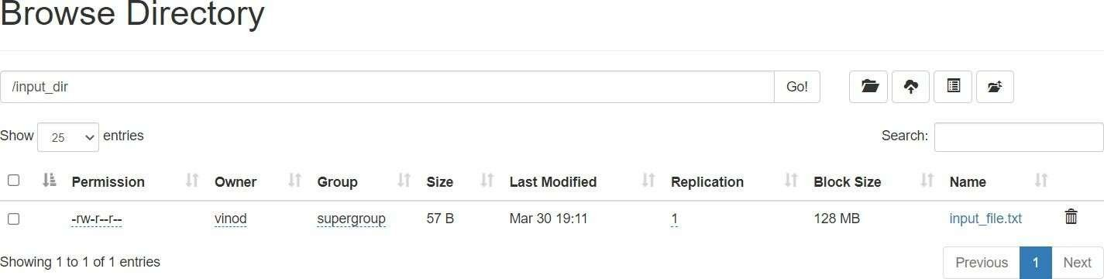
Verify input_file.txt available in HDFS input directory (input_dir). C:\>Hadoop fs -ls /input_dir/

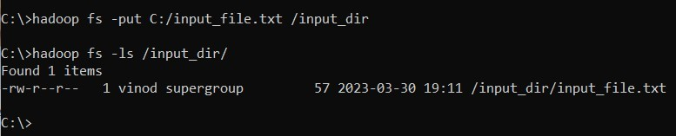
Verify content of the copied file
C:\>hadoop dfs -cat /input_dir/input_file.txt
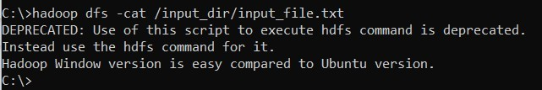
You can see the file content displayed on the CMD.
Run MapReduceClient.jar and also provide input and out directories.
C:\>hadoop jar C:/hadoop-3.3.0/share/hadoop/mapreduce/hadoop-mapreduce-examples-3.3.0.jar wordcount /input_dir /output_dir
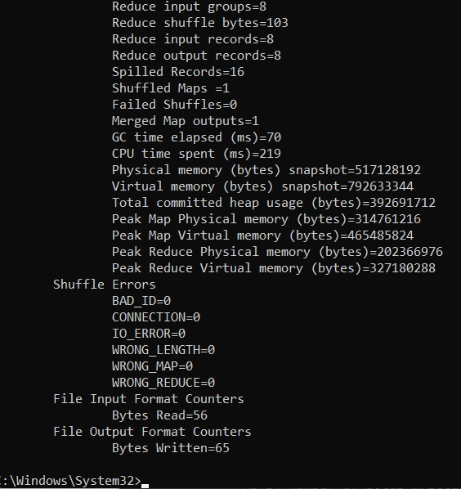
In case, there is some error in executing then copy the file MapReduceClient.jar in C:\ and run the program with the jar file using existing MapReduceClient.jar file as:
C:\> hadoop jar C:/MapReduceClient.jar wordcount /input_dir /output_dir Now, check the output_dir on browser as follows:

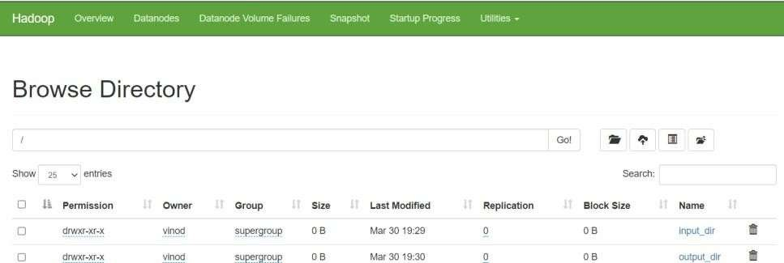
Click on output_dir → part-r-00000 → Head the file (first 32 K) and check the file content as the output.
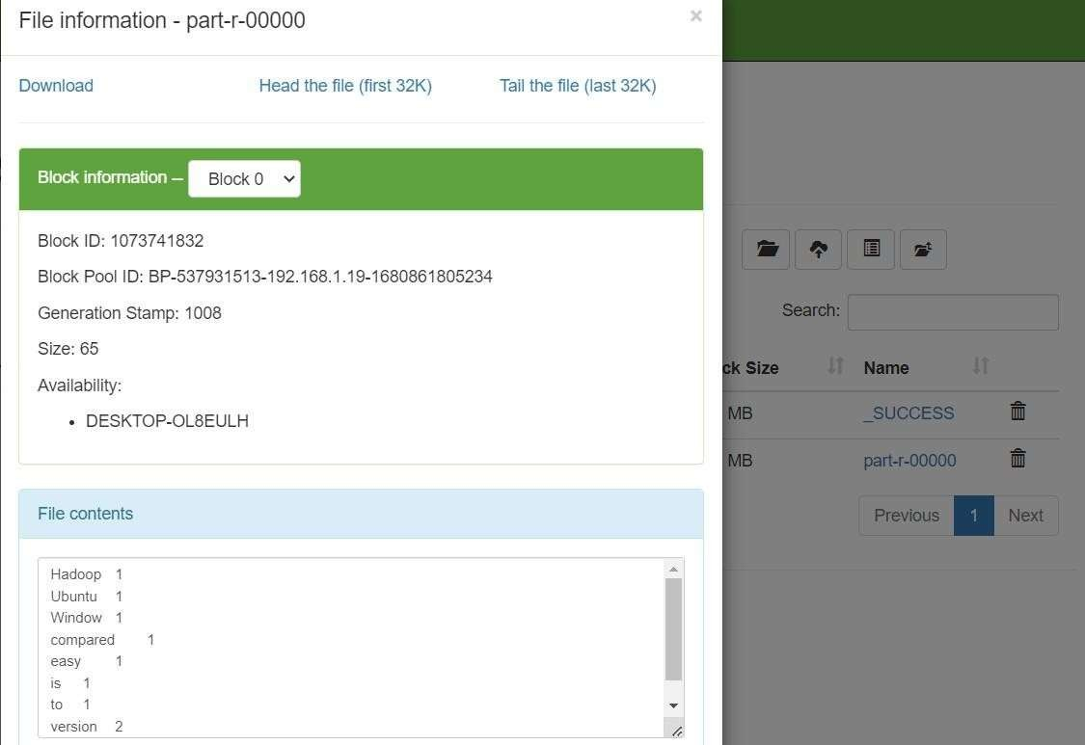

Alternatively, you may type the following command on CMD window as: C:\> hadoop dfs -cat /output_dir/*
You can get the following output
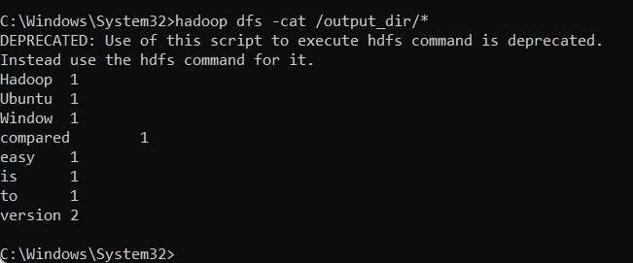
Output:

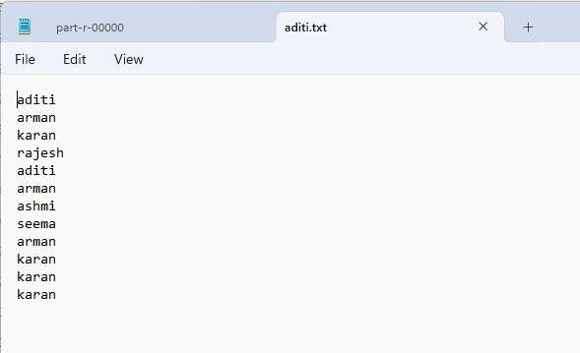
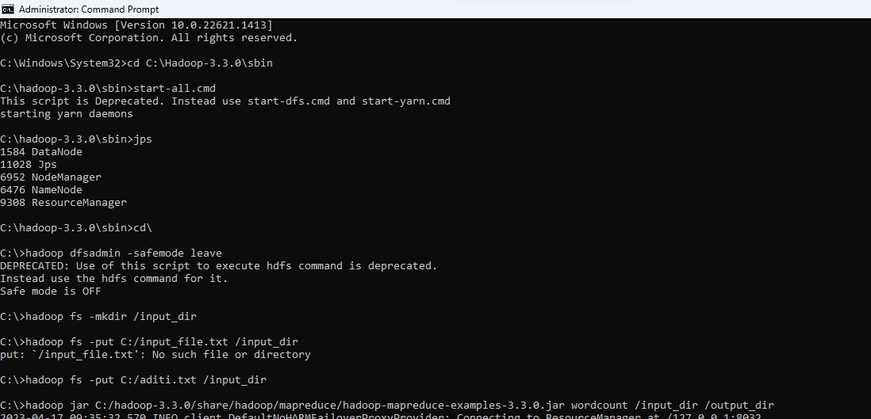


Practical 3
Aim :Implement an application that stores big data in Hbase / MongoDB and manipulate it using R / Python
- PyMongo
- Mongo Database

Step A: Install Mongo database
Step 1) Go to (https://www.mongodb.com/download-center/community) and Download MongoDB Community Server. We will install the 64-bit version for Windows.
Step 2) Once download is complete open the msi file. Click Next in the start up screen
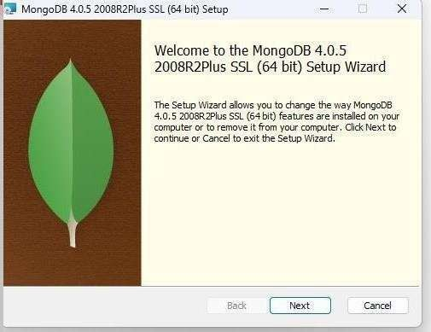
Step 3)
- Accept the End-User License Agreement
- Click Next
Step 4) Click on the "complete" button to install all of the components. The custom option can be used to install selective components or if you want to change the location of the installation.
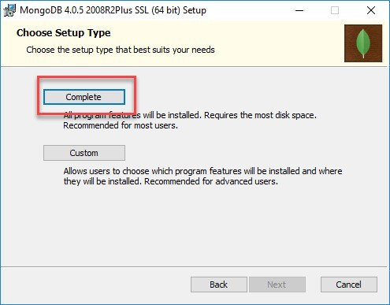

Step 5)
1. Select “Run service as Network Service user”. make a note of the data directory,
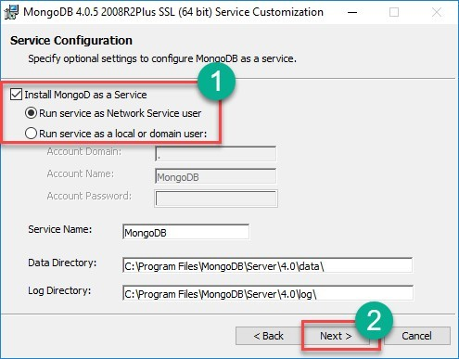
Step 6) Click on the Install button to start the installation.
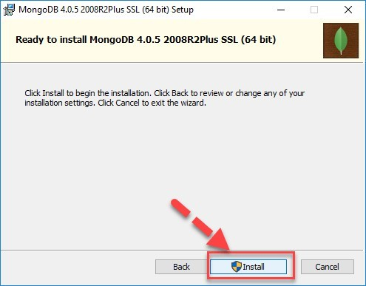
Step 7) Installation begins. Click Next once completed.

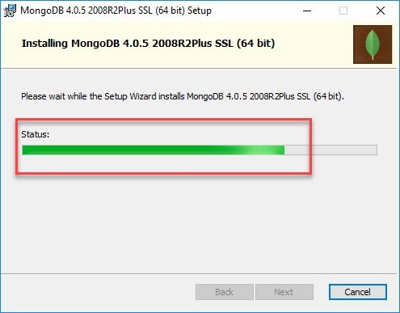
Step 8) Click on the Finish button to complete the installation
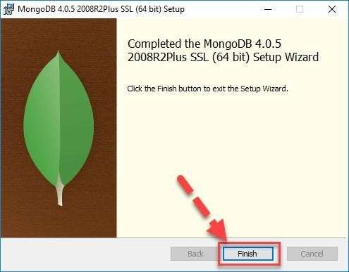

Test Mongodb
Step 1) Go to " C:\Program Files\MongoDB\Server\4.0\bin" and double click on mongo.exe.
Alternatively, you can also click on the MongoDB desktop icon. Create the directory where MongoDB will store its files.
Open command prompt window and apply following commands C:\users\admin> cd\
C:\>md data\db
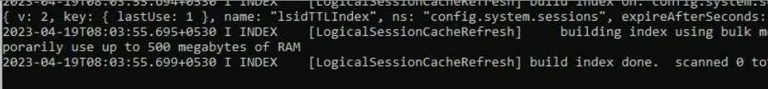

Step 2) Execute mongodb
Open another command prompt window.
C:\> cd C:\Program Files\MongoDB\Server\4.0\bin C:\Program Files\MongoDB\Server\4.0\bin> mongod
In case if it gives an error then run the following command:
C:\Program Files\MongoDB\Server\4.0\bin> mongod –repair

Step 3) Connect to MongoDB using the Mongo shell
Let the MongoDB daemon to run.
Open another command prompt window and run the following commands: C:\users\admin> cd C:\Program Files\MongoDB\Server\4.0\bin C:\Program Files\MongoDB\Server\4.0\bin>mongo
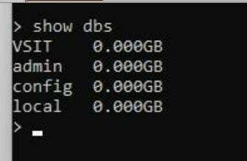

Step 4) Install PyMongo
Open another command prompt window and run the following commands:
Check the python version on your desktop / laptop and copy that path from window explorer
C:\users\admin>cd C:\Program Files\Python311\Scripts
C:\Program Files\<Python38>\Scripts > python -m pip install pymongo

Step 5) Test PyMongo
Run the following command from python command prompt

import pymongo
Now, either create a file in Python IDLE or run all commands one by one in sequence on Python cell

Program 1: Displaying the database name:

import pymongo
myclient = pymongo.MongoClient("mongodb://localhost:27017/") mydb = myclient["mybigdata"] print(myclient.list_database_names())

Output:

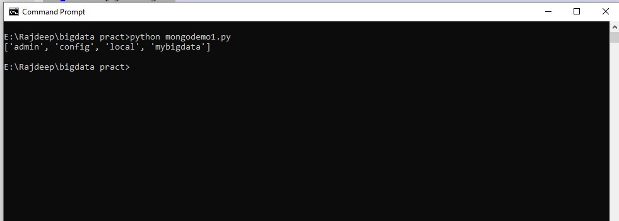

Program 2: Creating collection:

import pymongo
myclient = pymongo.MongoClient("mongodb://localhost:27017/") mydb = myclient["mybigdata"]
mycol=mydb["student"] print(mydb.list_collection_names()) Output:
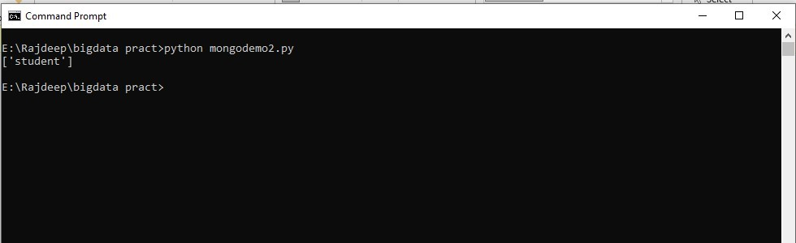

Program 3: Inserting Data

import pymongo
myclient = pymongo.MongoClient("mongodb://localhost:27017/") mydb = myclient["mybigdata"]
mycol=mydb["student"] mydict={"name":"vai", "address":"bhy"} x=mycol.insert_one(mydict)
print("Data inserted !")

Output:

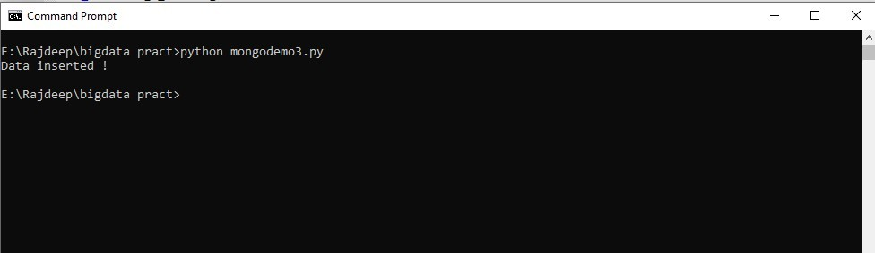

Program 4: Insert Multiple data into Collection

import pymongo
myclient = pymongo.MongoClient("mongodb://localhost:27017/") mydb = myclient["mybigdata"]
mycol=mydb["student"]
mylist=[{"name":"Ganesh", "address":"Mumbai"}, {"name":"Varun", "address":"Mumbai"},
{"name":"Prasoon", "address":"Pune"}, {"name":"Satish", "address":"Pune"},] x=mycol.insert_many(mylist)
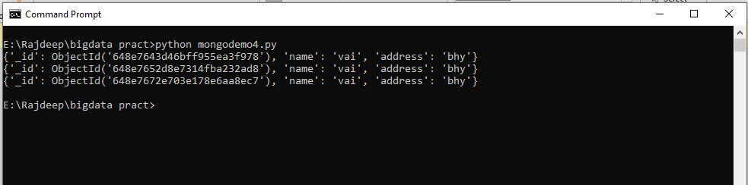
print("Data inserted !") Output:

Program 5: Displaying the collection data:

import pymongo
myclient = pymongo.MongoClient("mongodb://localhost:27017/") mydb = myclient["mybigdata"]
mycol = mydb["student"] myquery = { "name": "Vai" } mydoc = mycol.find(myquery)
for x in mydoc: print(x)
Output:

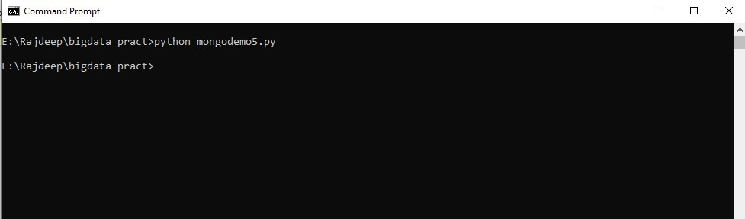

Practical 4
Aim: Implement Decision tree classification techniques

Code-
library("party") print(head(readingSkills)) str(iris)
iris_ctree <- ctree(Species ~ Sepal.Width + Sepal.Length + Petal.Length + Petal.Width, data=iris)
print (iris_ctree) plot(iris_ctree)

output
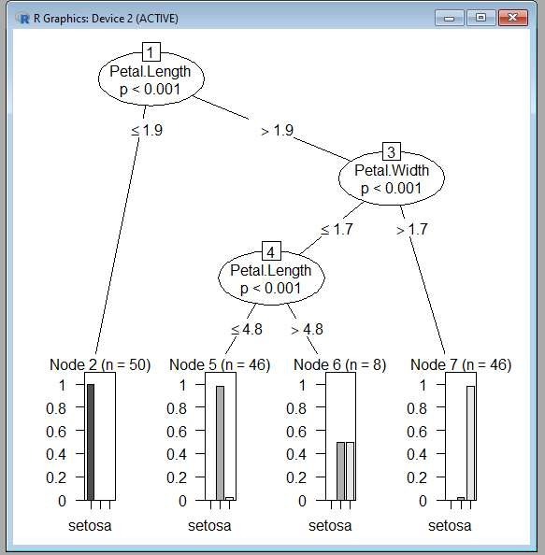

Practical 5
Aim: Implement SVM classification
techniques Code-
# Importing the dataset
dataset = read.csv(' E:/NIKHILESH/social.csv')

# Selecting relevant columns: Age, EstimatedSalary, Purchased dataset = dataset[3:5]

# Encoding the target feature as factor
dataset$Purchased = factor(dataset$Purchased, levels = c(0, 1))

# Splitting the dataset into the Training set and Test set install.packages('caTools') # Run only once library(caTools)
set.seed(123)
split = sample.split(dataset$Purchased, SplitRatio = 0.75) training_set = subset(dataset, split == TRUE)
test_set = subset(dataset, split == FALSE)

# Feature Scaling
training_set[-3] = scale(training_set[-3]) test_set[-3] = scale(test_set[-3])

# Fitting SVM to the Training set install.packages('e1071') # Run only once library(e1071)
classifier = svm(formula = Purchased ~ ., data = training_set,
type = 'C-classification',

kernel = 'linear')

# Predicting the Test set results
y_pred = predict(classifier, newdata = test_set[-3])

# Making the Confusion Matrix cm = table(test_set[, 3], y_pred) print("Confusion Matrix:") print(cm)

# Visualising the Training set results install.packages("ElemStatLearn") # Run only once library(ElemStatLearn)

# Plotting function (for training and test sets) plot_svm <- function(set, title) {
X1 = seq(min(set[, 1]) - 1, max(set[, 1]) + 1, by = 0.01)
X2 = seq(min(set[, 2]) - 1, max(set[, 2]) + 1, by = 0.01) grid_set = expand.grid(X1, X2)
colnames(grid_set) = c('Age', 'EstimatedSalary') y_grid = predict(classifier, newdata = grid_set) plot(set[, -3],
main = title,
xlab = 'Age', ylab = 'Estimated Salary', xlim = range(X1), ylim = range(X2))
contour(X1, X2, matrix(as.numeric(y_grid), length(X1), length(X2)), add = TRUE) points(grid_set, pch = '.', col = ifelse(y_grid == 1, 'springgreen3', 'tomato')) points(set, pch = 21, bg = ifelse(set[, 3] == 1, 'green4', 'red3'))
}

# Plot training and test results

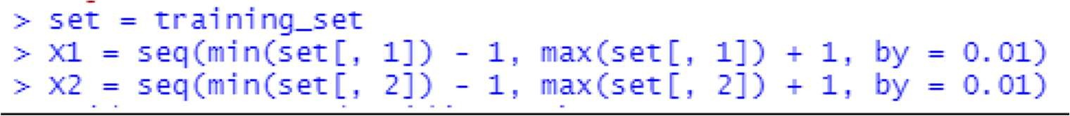
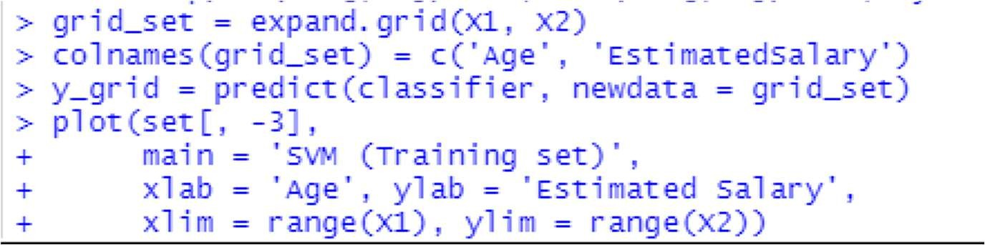
plot_svm(training_set, 'SVM Classification (Training set)')

Output:
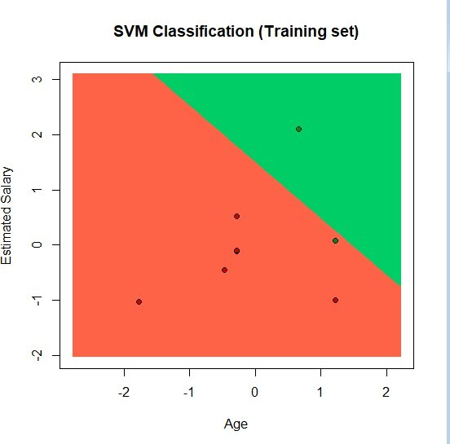
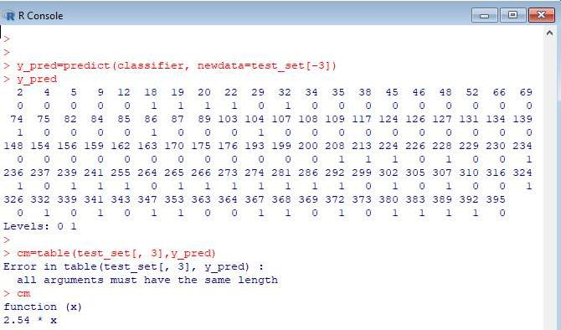

Practical 6
Aim : REGRESSION MODEL Import a data from web storage. Name the dataset and now do Logistic Regression to find out relation between variables that are affecting the admission of a student in an institute based on his or her GRE score,
GPA obtained and rank of the student. Also check the model is fit or not. require (foreign), require(MASS).
Linear regression practical

code-
# Load dataset college <-
read.csv("https://raw.githubusercontent.com/ropensci/datapack/main/inst/extdata/pkg-example/binary.csv")
head(college) nrow(college)
# Install and load caTools install.packages("caTools") # Run only once library(caTools)

# Split dataset set.seed(123)
split <- sample.split(college$admit, SplitRatio = 0.75) training_reg <- subset(college, split == TRUE) test_reg <- subset(college, split == FALSE)
# Fit logistic regression model
fit_logistic_model <- glm(admit ~ ., data = training_reg, family = "binomial")

# View coefficients coef(fit_logistic_model)["gre"] coef(fit_logistic_model)["gpa"] coef(fit_logistic_model)["rank"]

# Predict probabilities on test data
predict_reg <- predict(fit_logistic_model, newdata = test_reg, type = "response")

# Plot Conditional Density cdplot(as.factor(admit) ~ gpa, data = college) cdplot(as.factor(admit) ~ gre, data = college) cdplot(as.factor(admit) ~ rank, data = college)

# Convert probabilities to binary predictions predict_binary <- ifelse(predict_reg > 0.5, 1, 0)

# Confusion Matrix
table(Actual = test_reg$admit, Predicted = predict_binary)

output
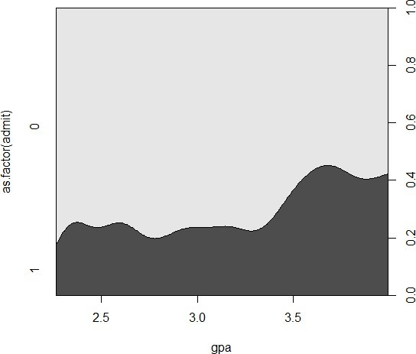
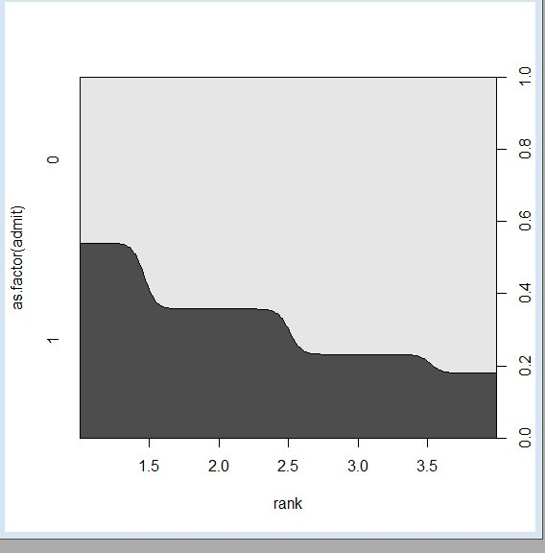

Practical 7

Aim: MULTIPLE REGRESSION MODEL: Apply multiple regressions, if data have a continuous independent variable. Apply on above dataset.
Code-
Explain Multiple regression in detail. # Load dataset
college <- read.csv("https://raw.githubusercontent.com/csquared/udacity-dlnd/master/nn/binary.csv")
head(college) nrow(college)

# Install and load caTools (only run install once) install.packages("caTools") # Only the first time library(caTools)

# Data splitting set.seed(123)
split <- sample.split(college$admit, SplitRatio = 0.75) training_reg <- subset(college, split == TRUE) test_reg <- subset(college, split == FALSE)
# Fit logistic regression model
fit_MRegressor_model <- glm(formula = admit ~ gre + gpa + rank, data = training_reg, family = binomial)
# Predict probabilities on test set
predict_reg <- predict(fit_MRegressor_model, newdata = test_reg, type = "response") head(predict_reg)
# Classify predictions (threshold = 0.5) predict_class <- ifelse(predict_reg > 0.5, 1, 0)

# Plot conditional density plots cdplot(as.factor(admit) ~ gpa, data = college) cdplot(as.factor(admit) ~ gre, data = college) cdplot(as.factor(admit) ~ rank, data = college)

# Confusion matrix
table(Actual = test_reg$admit, Predicted = predict_class) Output
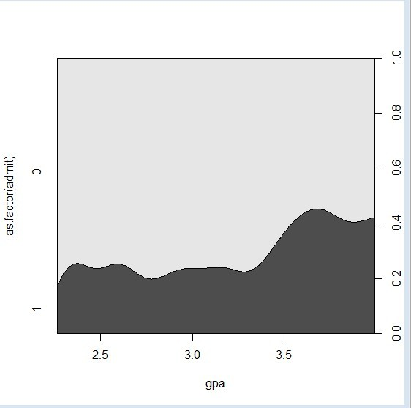

Practical 8

Aim :CLASSIFICATION MODEL a. Install relevant package for classification. b. Choose classifier for classification problem. c. Evaluate the performance of classifier.
Navebyse data(iris) str(iris)
install packages("e1071") install packages("caTools") install packages("caret") library(e1071) library(caTools) library(caret)
split <- sample.split(iris,SplitRatio=0.7) train_c1 <-subset(iris,split=="TRUE") test_c1 <- subset(iris,split == "FALSE") train_scale <- scale(train_c1[, 1:4]) test_scale <- scale(test_c1[,1:4])

set.seed(120)
classifier_c1 <- naiveBayes(Species ~ ., data = train_c1) classifier_c1

y_pred <- predict(classifier_c1, newdata= test_c1) cm <- table(test_c1$Species, y_pred)
cm
confusionMatrix(cm) data(iris) str(iris)
install packages("e1071") install packages("caTools") install packages("caret") library(e1071) library(caTools) library(caret)
split <- sample.split(iris,SplitRatio=0.7) train_c1 <-subset(iris,split=="TRUE") test_c1 <- subset(iris,split == "FALSE") train_scale <- scale(train_c1[, 1:4]) test_scale <- scale(test_c1[,1:4])
set.seed(120)
classifier_c1 <- naiveBayes(Species ~ ., data = train_c1) classifier_c1

output -

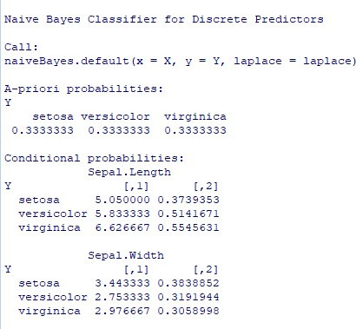

y_pred <- predict(classifier_c1, newdata= test_c1) cm <- table(test_c1$Species, y_pred)
cm confusionMatrix(cm) output-
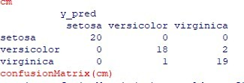

Practical 9
Aim : CLUSTERING MODEL a. Clustering algorithms for unsupervised classification.
b. Plot the cluster data using R visualizations.
install.packages("plyr") install.packages("ggplot2") install.packages("cluster") install.packages("lattice") install.packages("grid") install.packages("gridExtra") library(plyr)
library(ggplot2) library(cluster) library(lattice) library(grid) library(gridExtra)
grade_input=as.data.frame(read.csv("E:/Rajdeep/bigdata pract/dataset/grades_km_input.csv"))
kmdata_orig=as.matrix(grade_input[, c ("Student","English","Math","Science")]) kmdata=kmdata_orig[,2:4]
kmdata[1:10,] wss=numeric(15)
for(k in 1:15)wss[k]=sum(kmeans(kmdata,centers=k,nstart=25)$withinss) plot(1:15,wss,type="b",xlab="Number of Clusters",ylab="Within sum of square") km = kmeans(kmdata,3,nstart=25)
km
c( wss[3] , sum(km$withinss)) df=as.data.frame(kmdata_orig[,2:4]) df$cluster=factor(km$cluster) centers=as.data.frame(km$centers)
g1=ggplot(data=df, aes(x=English, y=Math, color=cluster )) + geom_point() + theme(legend.position="right") +
geom_point(data=centers,aes(x=English,y=Math, color=as.factor(c(1,2,3))),size=10, alpha=.3, show.legend =FALSE)
g2=ggplot(data=df, aes(x=English, y=Science, color=cluster )) + geom_point () +geom_point(data=centers,aes(x=English,y=Science, color=as.factor(c(1,2,3))),size=10, alpha=.3, show.legend=FALSE) g3 = ggplot(data=df, aes(x=Math, y=Science, color=cluster )) + geom_point () + geom_point(data=centers,aes(x=Math,y=Science, color=as.factor(c(1,2,3))),size=10, alpha=.3, show.legend=FALSE) tmp=ggplot_gtable(ggplot_build(g1))
grid.arrange(arrangeGrob(g1 + theme(legend.position="none"),g2 + theme(legend.position="none"),g3 + theme(legend.position="none"),top ="High School Student Cluster Analysis" ,ncol=1))

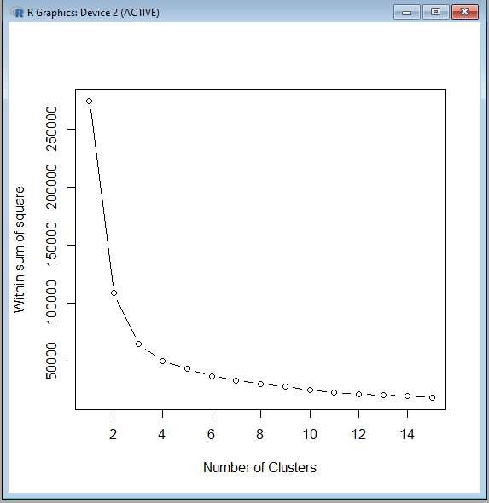
Aprori Practical code-
library(arules) library(arulesViz) library(RColorBrewer)

data(Groceries) Groceries

summary(Groceries) class(Groceries)
rules = apriori(Groceries, parameter = list(supp = 0.02, conf = 0.2)) summary (rules)

inspect(rules[1:10])

arules::itemFrequencyPlot(Groceries, topN = 20, col = brewer.pal(8, 'Pastel2'),
main = 'Relative Item Frequency Plot', type = "relative",
ylab = "Item Frequency (Relative)")

itemsets = apriori(Groceries, parameter = list(minlen=2, maxlen=2,support=0.02, target="frequent itemsets"))
summary(itemsets) inspect(itemsets)

itemsets_3 = apriori(Groceries, parameter = list(minlen=3, maxlen=3,support=0.02, target="frequent itemsets"))
summary(itemsets_3)

inspect(itemsets_3)
output-
